

Hypermedia Applications a.y. 2018/19

Usability Evaluation Report 04/07/19

**Alessandro Carughi – alessandro.carughi@mail.polimi.it**

**Luca Maltagliati – luca.maltagliati@mail.polimi.it**

**Marco Turetta – marco3.turetta@mail.polimi.it**

Abstract

The following document aims at resuming the results of the **Usability Study** conducted by our team for the evaluation of the following website <http://www.pngp.it/>.

The main **goal** of our report and of our study was to evaluate the website among this step:

1. **Inspection**;
2. **User Testing**;
3. **Reporting**: comparison of the results of the 2-evaluation process;

In the following we will illustrate and discuss the evaluation method adopted, along with the tools and instruments we used in order to accomplish our study.

Inspection

### About inspection report we first select which criteria is used for evaluating the heuristic score and then we done a table to report all this value to study which section of the site work well or not.

Finally, we report a short conclusion where we discuss the inspection result.

### **Definition of heuristic:**

* + **Navigation Heuristic:**
* Interaction consistency (H1): do pages of the same type have the same links and interaction capability?
* Group Navigation (H2): is it easy to navigate among group members and from a group introductory page to group members (and the other way around)?
* Structural Navigation (H3): is it easy to navigate among the semantic components of a topic?
* Semantic Navigation (H4): is it easy to navigate from a topic to a related one?
* Landmarks (H5): are landmarks useful to reach the key parts of the web site?
  + **Content**
* Information overload (H6): is the information in a page too much/too little?
  + **Layout**
* Text layout (H7): is the text readable?
* Interaction Placeholder (H8): are textual or visual labels of interactive elements “expressive” and they reflect the meaning of the interaction and its effects?
* Spatial Allocation (H9): is the on-screen allocation of contents and visual appropriate for their relevance?
* Consistency of page structure (H10): do pages of the same type have the same layout?

|  |  |  |  |  |
| --- | --- | --- | --- | --- |
| Category | Heuristic | Score | | Comment |
| Navigation | | | | |
|  | H1 | 4 | All the pages have the same header and the same footer | |
|  | H2 | 3 | It works fine, but the navigation is a little clunky, when the user goes to the internal pages there is not a back button that could be useful to keep track of the navigation | |
|  | H3 | 4 | Yes, because all the components of a topic are showed on the left side menu when a topic is open | |
|  | H4 | 3 | It easy to navigate from one topic to a related one, but it can be simpler if the pages contain more information | |
|  | H5 | 5 | Landmarks work well | |
| Content | | | | |
|  | H6 | 3 | Some pages could be aggregated, look H4 | |
| Layout | | | | |
|  | H7 | 3 | Is readable but there are too many texts and you can lose the point easily | |
|  | H8 | 2 | Nearly almost every button has the same form, so you have to read all the text to search where to go | |
|  | H9 | 3 | Some pages can be unified because there are too many buttons that can create a confusion in the website | |
|  | H10 | 4 | All the pages, excluded the index page, have the same layout | |

**H1**: All the pages, unless the index, have the same structure, so it easy to understand that all the link and interaction have the same capability.

**H2**: the website presents a “back button” that is not clearly define, so maybe is not easy to return to the previous page unless click the landmark correlated to it.  
This process could be annoying.

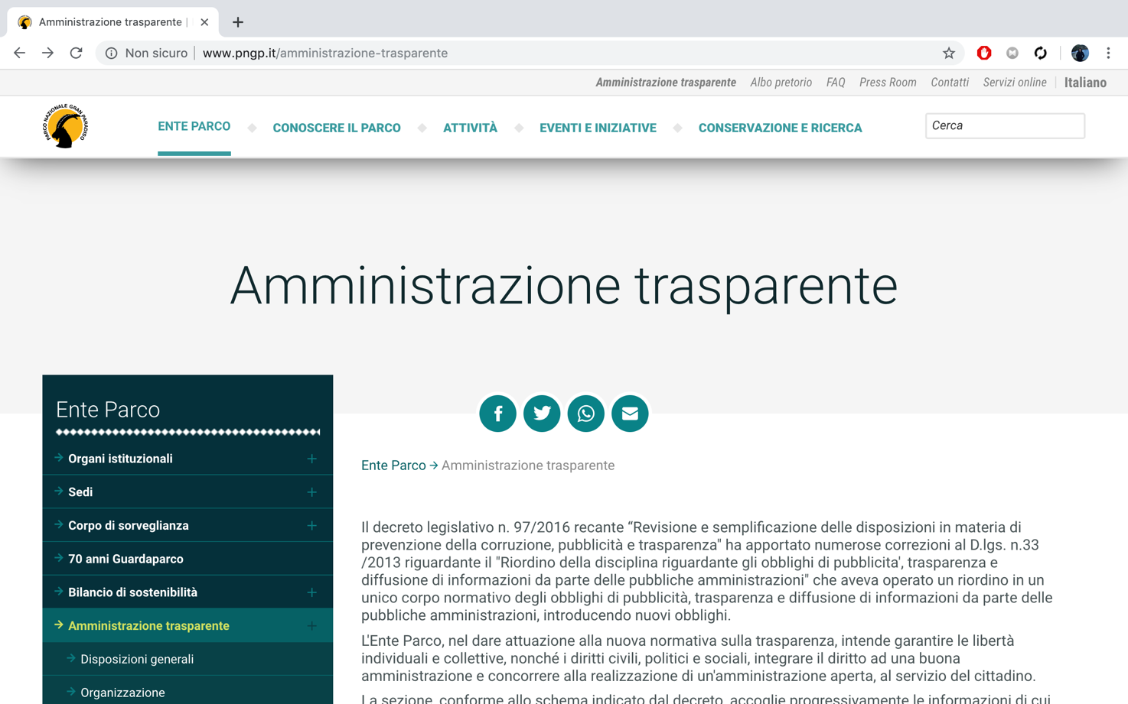

**H3**: The left side menu collocated in all pages are useful to reach all the components of a single topic

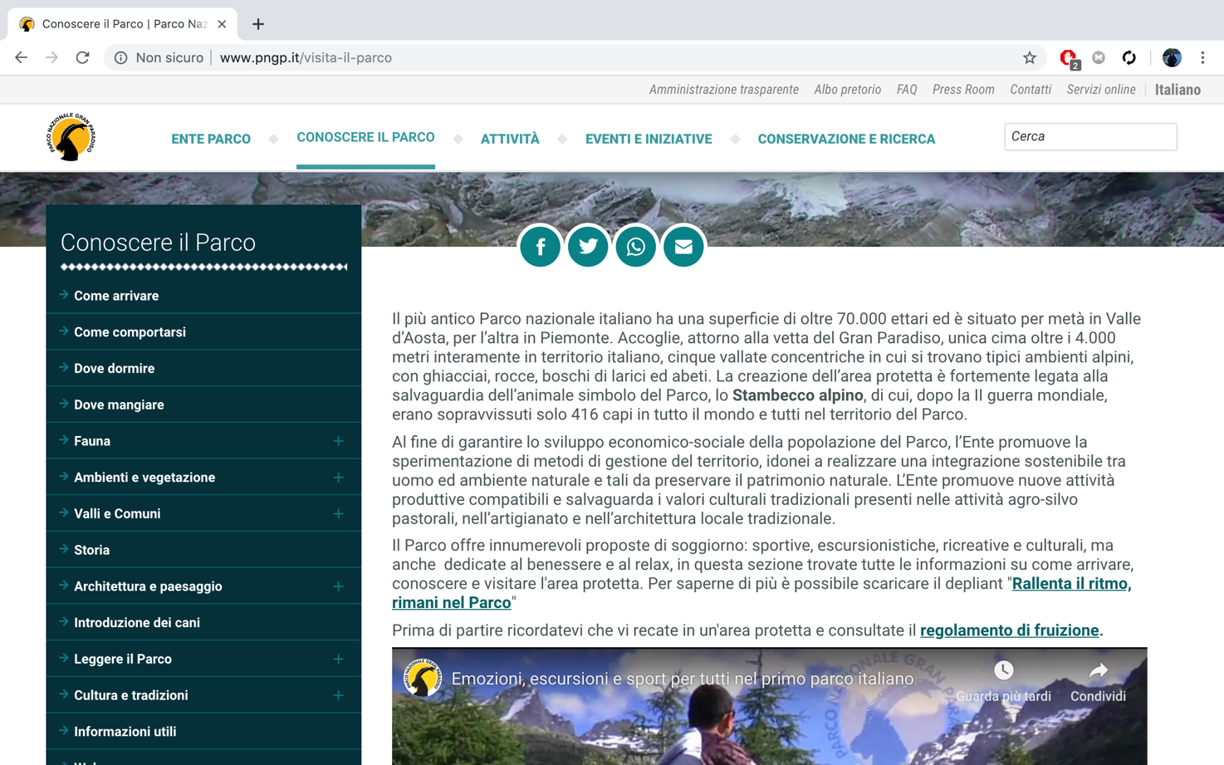

**H4**: Basically, is simple to navigate from one page to one correlated, but it may be repetitive if a use want to see all the information about a single topic, because he have to continuing switching the page due to the less information written in some page.  
For example in the following screen we see that the “Ambienti e vegetazione” section could be summarized in only one page.

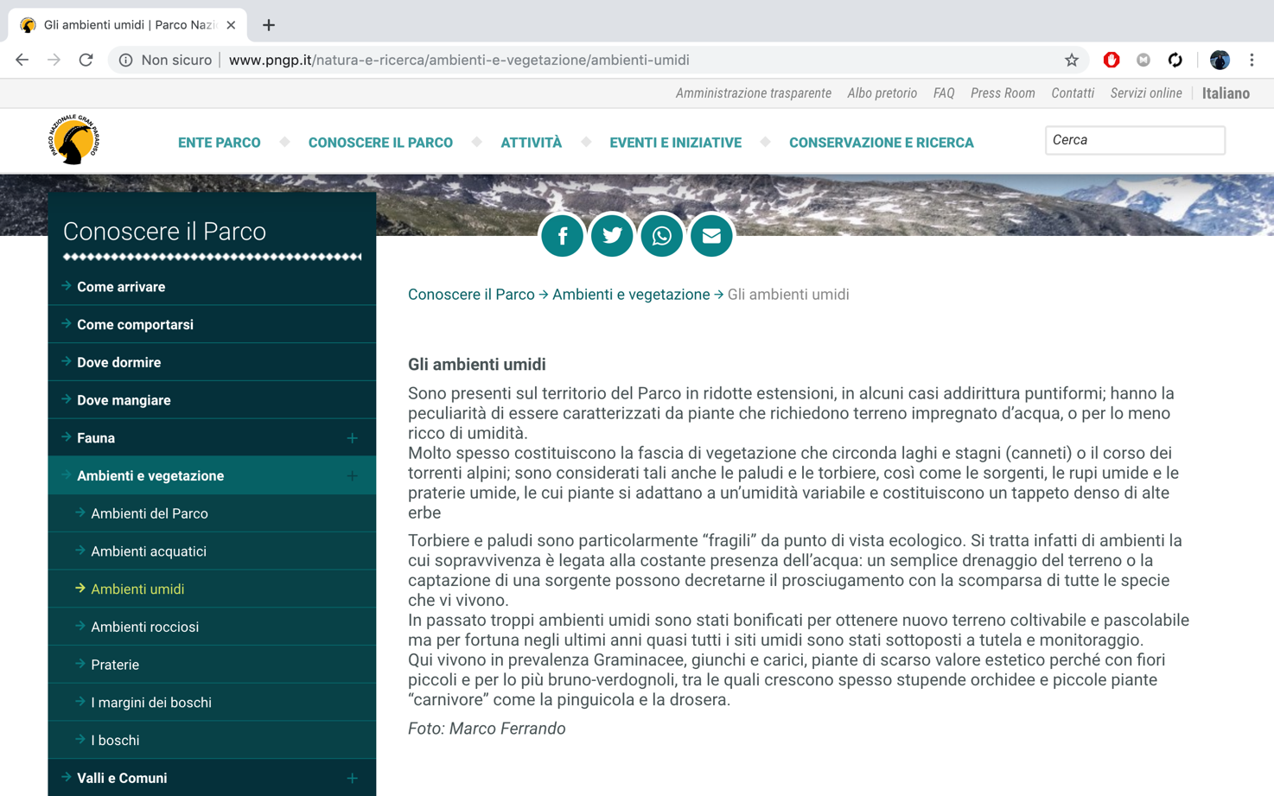

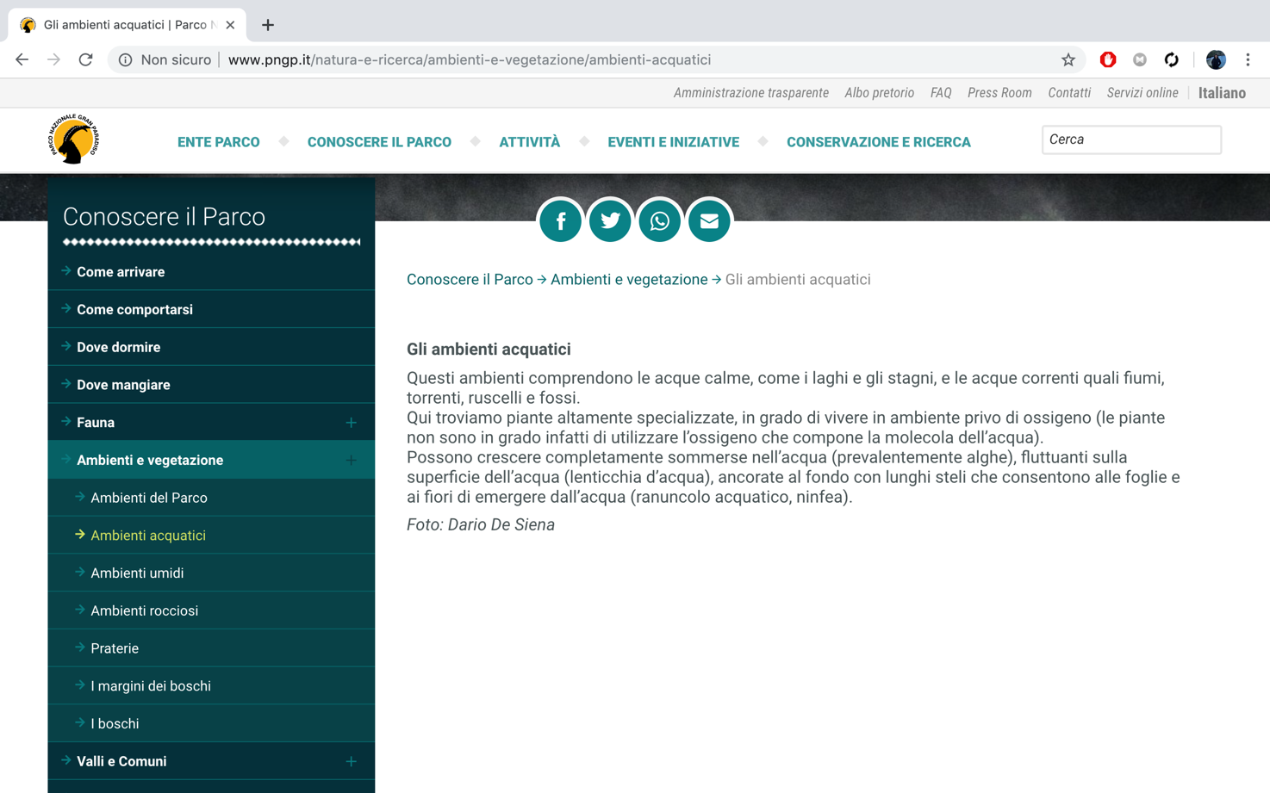

**H5**: The landmark that are presented on the site are all useful to reach the key part of the website.

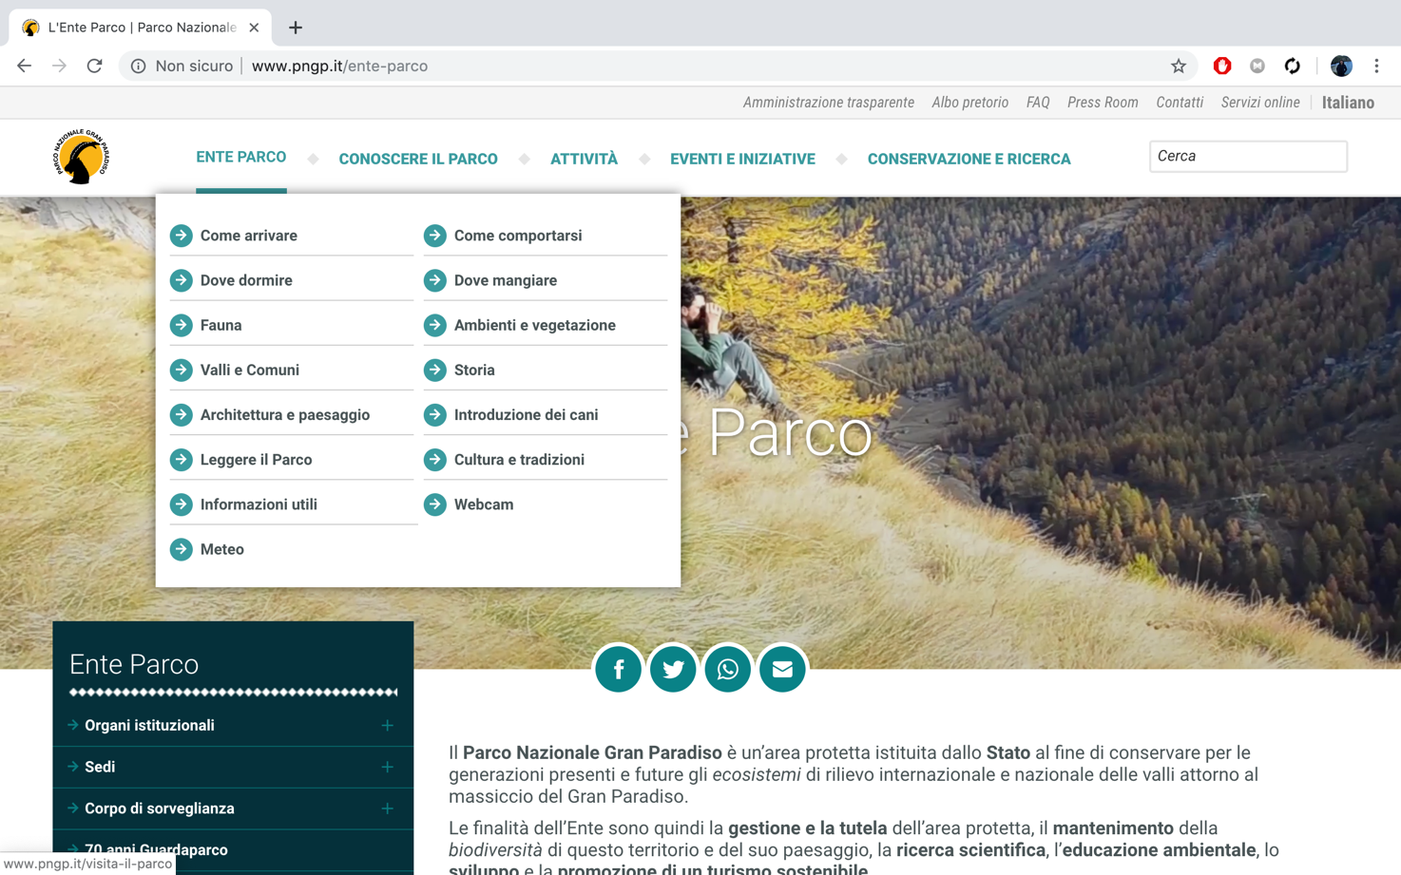

**H6**: Look H3

**H7**: The text is readable but, in some pages, like the screenshot that are reported, there are too much text that can create a bit of confusion.

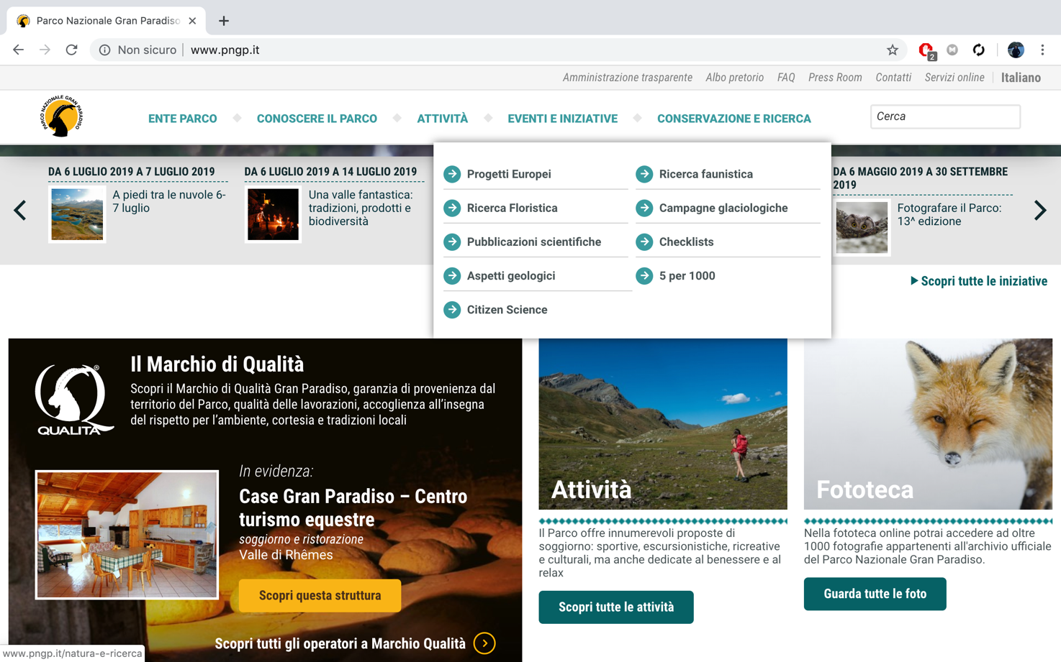

**H8**: Due to the similarity of all the button, you have to read all the text to search where to go.

**H9**:

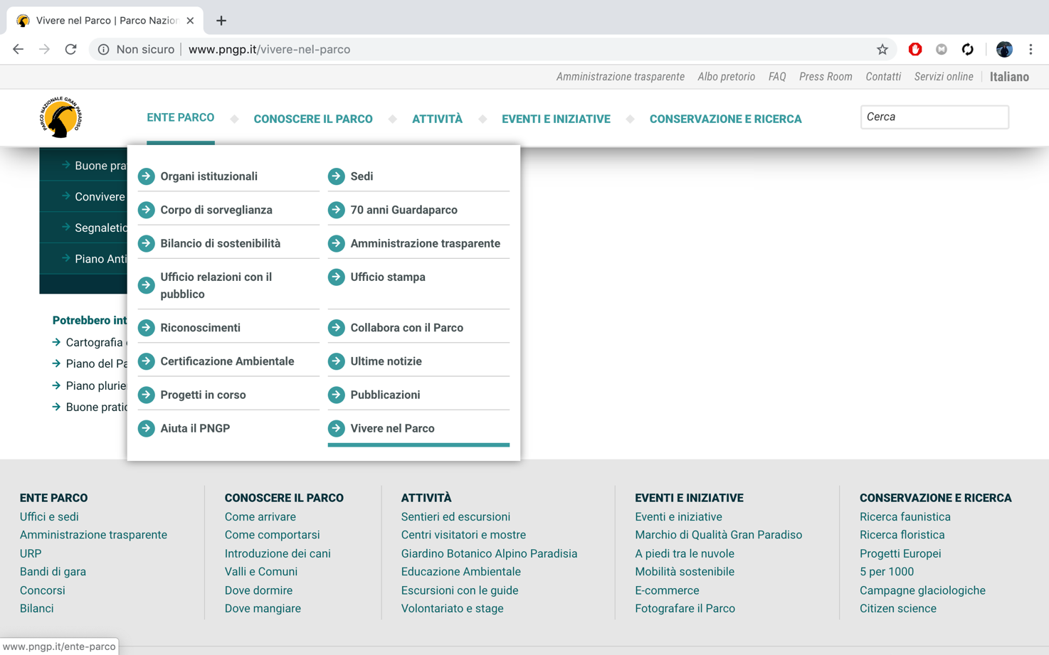

**H10**:

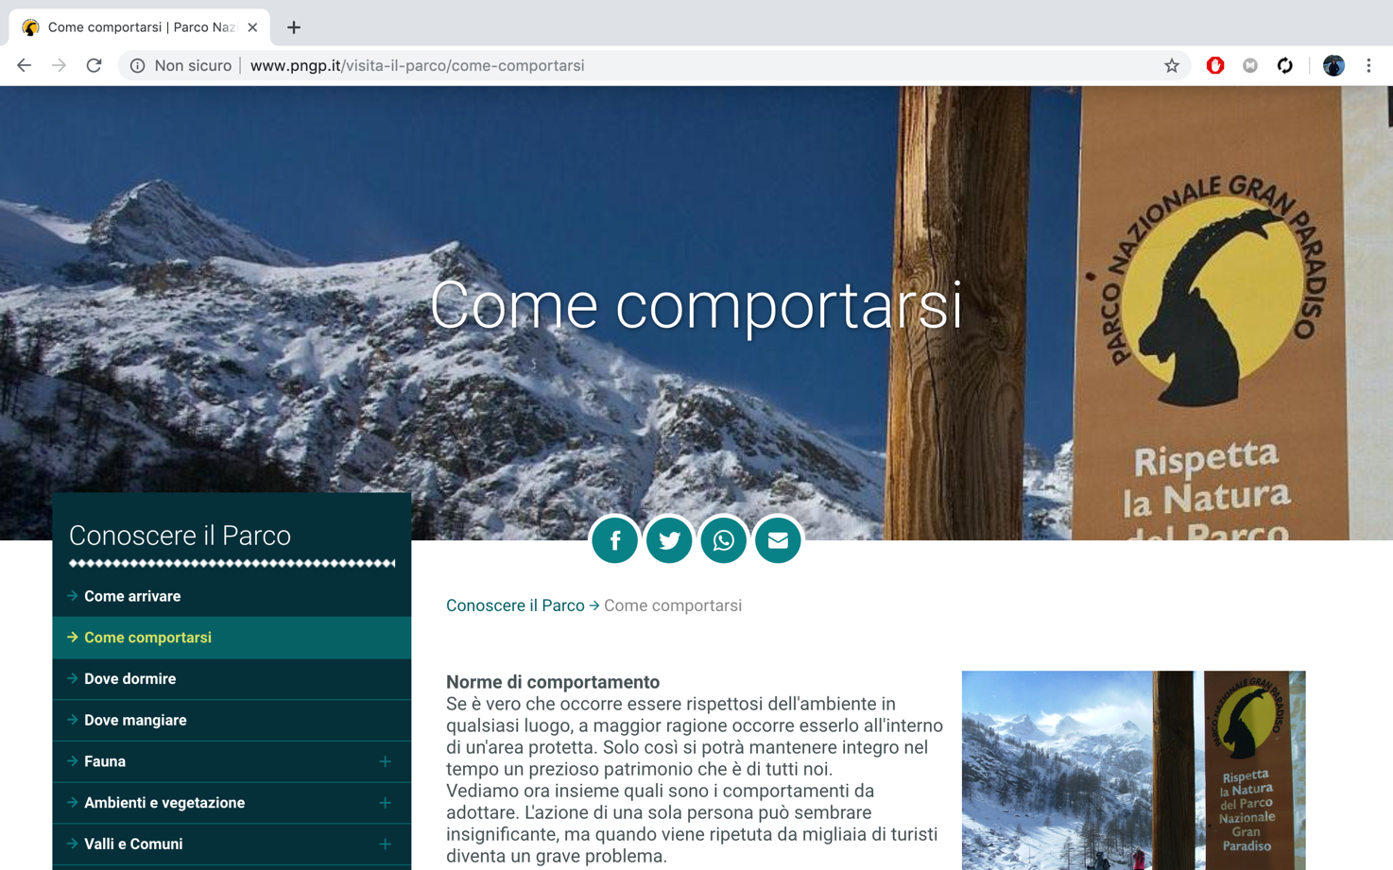

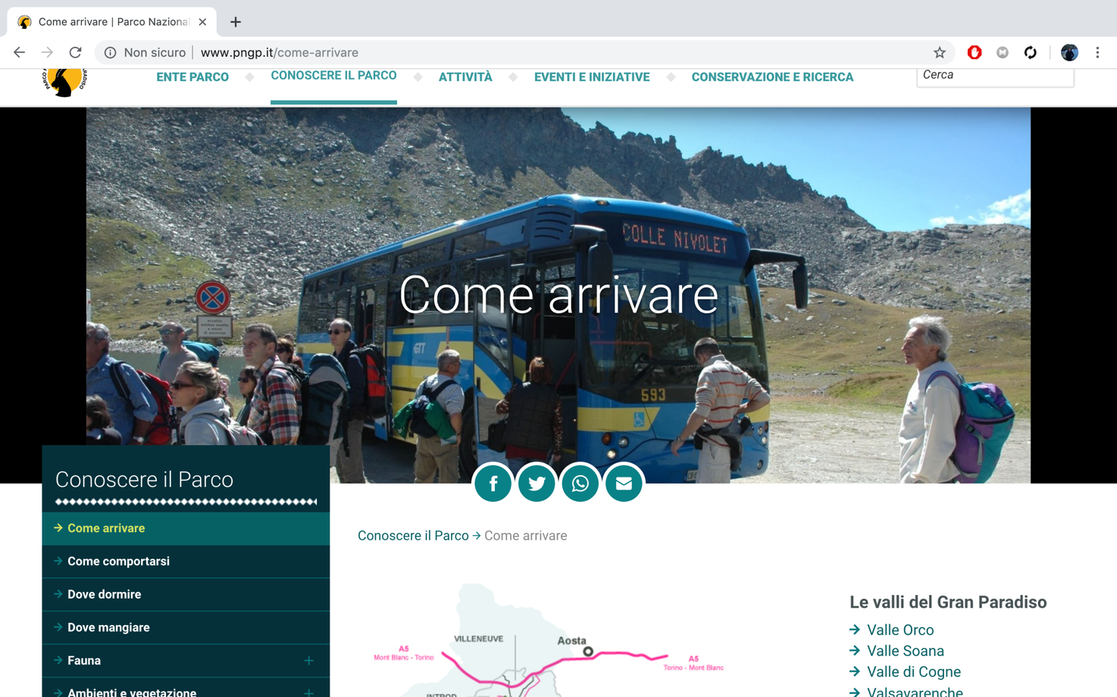

### **Data Analysis:**

### Follow we provide the aggregated data of the heuristic evaluation.

**Total Heuristic Value:** 3,27

### **Conclusion:**

* Include a short conclusion section where you briefly discuss inspection results

User testing

Briefly describe:

* Design of the study
* How/where/when it was executed
* Results - please provide aggregated data (e.g. Mean values for the various measures, diagrams, etc.) in numerical and visual form
* Short discussion of results

**Design**

GOALS

1 To uncover actual difficulties that users have when interacting with the application

2 To obtain a systematic feedback on the effectiveness and efficiency of use of your product

Usability report

User testing

3 Users

One profile:young man

Measures:

Quantitative

• Efficiency (time on task)

• Errors (wrong paths or actions)

• Perceived tasks difficulty

Qualitative:

* Disorientation,
* stops,
* frustrations,
* waiting periods,
* wandering periods

Tasks:

Define 3 tasks!!!

Recruitment:

Avoid mixing first time users and frequent users – Do not take users who are not familiar with interacting with computers/web in general – You can use more “generic” profiles (e.g. extending the age range, but keep the tasks constant) – Set out to get comparable results across participants

EXECUTION

How where when

HOW

-We pretested the test

-we introduced users to the test

-we made users perform the task on the app

-tools used to help the tester

-we collected the usability measures via TOOL

WHERE

-Class room

WHEN

Reporting

**Comparisons** of the results the 2 evaluation process